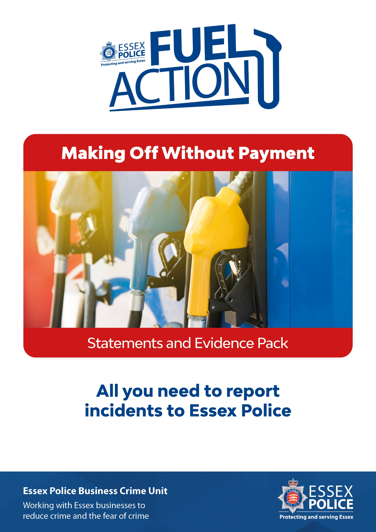
Version: Q3 2020

REMEMBER: Is a crime happening right now, is the suspect still at the scene, or is anyone seriously injured or in immediate danger? – If YES, dial 999

Contents:
- Making Off Without Payment incident recording sheet
- Impact statement for business form
- MG11 Witness Statement form

Recording Pack Checklist:

- If you plan on completing statements later, complete the Incident Recording Sheet so the information is clear to refer to later when you complete your statement.
- Report the incident to Essex Police online at https://www.essex.police.uk/do-it-online/report-a-crime/ or by telephoning 101

  - The online page consists of a few easy to answer questions including:
  - ‘Is there an immediate threat to safety?’
  - ‘Is the suspect still on scene’
  - The address of the offence
  - Your personal contact details
  - And a short description of what has happened.

  - You will receive an online submission reference number and subsequently sent a Crime Reference number.

- Fill out the Pro Forma Statement. Remembering that each person involved needs to complete a statement.

- Copy any CCTV evidence and place into the completed evidence bag

- If you know the exact amount stolen, please place a copy of a receipt or invoice with your statement.

You are sending back:
- Incident Brief Sheet
- Statements
- Copy of CCTV
- Receipt or invoice

Making Off Without Payment Incident Recording Sheet

Incident Details | Exhibit Number:
Business Name
Staff witness name
Person recording
(if different to above)
Incident Time and Date
Have you reported any other incidents to Essex Police in the last 12 months?

Y / N
Have any incidents occurred in the last 12 months that you have not reported to Essex Police?

Y / N
Would you like to speak to the Business Crime Team to discuss crime prevention measures? | Y / N  You can contact the business crime unit at business.crime.unit@essex.police.uk

Vehicle | Registration Number:
 | Make:
 | Model:
 | Colour:
 | Number of occupants:
Suspect | Male / Female / Unknown:
 | Ethnicity:
 | Age:
 | Build:
 | Height:
Hair: Colour, Length & Style
Facial hair? Beard / Moustache / Side Burns?
Identifiable Features:
(Tattoos – design and position, Scars, piercings, missing body parts):
Accessories: (Glasses, Crutches, other things that might be carried with a person frequently)
Hat or scarf? Describe
Clothing top half of body:
Jacket, Shirt, etc. Colour and style. Note any manufacturers logo
Clothing bottom half of body:
Trousers, shorts, shoes, trainers. Again note any manufacturers logo.
Accent or dialect heard:
Fuel Stolen | Unleaded / Diesel / Other
 | Quantity Dispensed: |  | Litres
 | Value: |  | £
 | Pump Number used:
Who dispensed the fuel? | Driver / Front Passenger / Rear Passenger / Other
CCTV | Have you saved/marked up CCTV for retention? |  | Yes / No
When a copy is made, it becomes the exhibit of the person who made it. On the front of the exhibit bag it will ask you for an exhibit number. This will be made from your initials and then a number.
So, if it is the first exhibit from John Smith, the exhibit number will be JS/1.
NOTE: This Incident Brief Sheet will also become an exhibit and therefore requires an exhibit number. You will find a space for this number on the statement.
Other Evidence: | Is there any Blood, are there Bodily Fluids, Discarded Items or possibilities for obtaining Fingerprints? If so – What?
 | Was anything else stolen or damaged? If so, note items and value:
 | Was anyone threatened/verbally abused/assaulted?
 | What makes you believe a crime has been committed?
Reporting: | The incident can now be reported in two ways:  - Online at https://www.essex.police.uk/do-it-online/report-a-crime/  The online form will prompt you and give you time to fill in each section when convenient to do so.  - By calling 101. Give as much detail as possible from your notes on this form.
An incident, online submission and/or crime reference number will be generated.

Incident number _ _ _ _ _ _ _ _ _ _ _ _ _ _ _ _ _ _ _ _ _ _ _ _ _ _ _ _ _ _ _ _ _ _ _ _ _ _

Online submission reference _ _ _ _ _ _ _ _ _ _ _ _ _ _ _ _ _ _ _ _ _ _ _ _ _ _ _ _ _ _ _

Crime reference _ _ _ _ _ _ _ _ _ _ _ _ _ _ _ _ _ _ _ _ _ _ _ _ _ _ _ _ _ _ _ _ _ _ _ _ _ _

WITNESS STATEMENT
Version:1.10.0.3
Hash:zhESYbq6oXGkwMOe3MNxYiXhEzk=

Criminal Procedure Rules, r. 16.2;Criminal Justice Act 1967, s. 9; Magistrates’ Courts Act 1980, s.5B

URN
Statement of:
Age if under 18: (if over 18 insert ‘over 18’) Occupation:
This statement (consisting of 4 page(s) each signed by me) is true to the best of my knowledge and belief and I make it knowing that, if it is tendered in evidence, I shall be liable to prosecution if I have wilfully stated in it anything which I know to be false, or do not believe to be true.

Signature:................................................................................ (witness) Date:

I confirm that I am the person named above and I have been asked by Essex Police to provide details of a making off without payment at my place of work.
Version:1.10.0.3
Hash:+06dVJomMlaqDwQUwx0mzVdkcZ8=

At this time I am employed by____________ service station__________________________________________ (Organisation) to undertake the role of _________________________________________________. I have held this position for ___________________ (Months/Years)
At/Around _________________ Hours (Time) on ___________________________________ (Date) I was at ________________________________________________________________________________________________ (Location)
Whilst at this location I witnessed/Was informed of a making off without payment which had occurred.

From witnessing/being informed of this incident I would like to report the following (Please describe the chain of events witnessed or seen on CCTV)

Time of the incident ____________________________________________________________
Date of the incident ____________________________________________________________ What happened (Describe in chronological order what happened during the incident) __________________________ ____________________________________________________________________________ ____________________________________________________________________________ _______________________________________________________________________________________________________________________________________________________________________________________________________________________________________________________________________________________________________________________________________________________________________________________________________________________________________________________________________________________________________________________________________________________________________________________________________________________________________________________________________________________________________________________________________________________________________________________________________ (Please continue of separate sheet if necessary)

Please describe each person involved. Please include names, dates of birth (if known) and how the person is known to you. (Example of things to include are ethnicity, height, build, age, hair colour, hair style, marks, scars, tattoos, clothing whether you would recognise the person again and whether you had a full, unobstructed view of the person)
Person 1 ____________________________________________________________________________________________________________________________________________________________________________________________________________________________________________________________________________________________________________________________________________________________________________________________
Person 2 ____________________________________________________________________________________________________________________________________________________________________________________________________________________________________________________________________________________________________________________________________________________________________________________________
Person 3 ____________________________________________________________________________________________________________________________________________________________________________________________________________________________________________________________________________________________________________________________________________________________________________________________
The vehicle involved in this incident is a _______________________ (make) ______________________ (model) in the colour __________________. The vehicle displayed the registration plate of ____________________. The vehicle refuelled at pump number _____________. This is/is not a ‘Pay at Pump’ only pump. The driver/passenger refuelled ______________ litres of Petrol/diesel/LPG/Adblu at £____________ per litre. This had a total value of £_____________.
I can/cannot produce a receipt of this as my exhibit __________/_________ (Your initials / a sequential number).

There is/is not full CCTV footage of this making off without payment.

At _______________ (copying of CCTV time) hours on _______________________ (Copying of CCTV date)
I have produced the following CCTV footage from ____________________________________
___________________________________________________________ (Location where CCTV is from)

The start time and date shown on the CCTV footage displays as ____________________ (Time) __________________________________________ (Date)
The end time and date shown on the CCTV footage displays as ____________________ (Time) __________________________________________ (Date)

The CCTV system does/does not (delete as necessary) run at the correct time and date. It runs _____________________ slow/fast. (Complete if necessary)

I can produce this as my exhibit __________/_________ (Your initials / a sequential number). Once I had made a copy of this CCTV I placed it in the CCTV evidence bag with the reference _H______________________ and sealed it.

The driver/passenger did/did not attempt to pay for the fuel. (If attempt to pay was made please detail below and record why the attempt was not successful)

________________________________________________________________________________________________________________________________________________________________________________________________________________________________________________________________________________________________________________________________________________________________________________________________________________________________________________________________________________________________________________________________________________________________________________________________________________________________

I can confirm that no one has any permission to take fuel without making a valid for of payment for it. I fully support a police investigation into this matter and I am willing to attend Court for this matter if required.

NOT DISCLOSABLE
Witness Details |  |  |  |  |  |  |  |  |  |  |  |  |  |  |  | URN
Name of witness:
Home address: |  |  |  |  |  |  |  |  |  |  |  |  |  |  |  |  |  |  |  | Postcode:
Home Tel No.: |  |  |  |  |  |  |  |  |  |  | Work Tel No.:
Mobile Tel No.: |  |  |  |  |  |  |  |  |  |  | Email address:
Preferred means of contact (specify details for vulnerable/intimidated victims and witnesses only):
Gender: Male Female |  |  |  |  |  |  | Date & place of birth:
Former name: |  |  |  |  |  |  |  |  |  |  |  |  |  |  |  | Ethnicity Code (16 + 1):
Dates of Witness Non-Availability:
Witness care (Please tick or type in box provided)
a) Is the witness willing to attend court? If ‘No’, include reason(s) on form MG6. |  |  |  |  |  |  |  |  |  |  |  |  |  |  |  |  |  |  |  |  | Yes No
b) Does the witness have any concerns about attending court and if so what support measures can be offered to ensure attendance?
c) Does the witness require a Special Measures Assessment as a vulnerable or intimidated witness? (youth under 18; witness with mental disorder, learning or physical disability; or witness in fear of giving evidence or witness is the complainant in a sexual offence case)?  If ‘Yes’ submit MG2 with file in anticipated not guilty, contested or indictable only cases. |  |  |  |  |  |  |  |  |  |  |  |  |  |  |  |  |  |  |  |  | Yes No
d) Does the witness have any particular needs? If ‘Yes’ what are they? (Disability, healthcare, childcare, transport, disability, language difficulties, visually impaired, restricted mobility or other concerns?) |  |  |  |  |  |  |  |  |  |  |  |  |  |  |  |  |  |  |  |  | Yes No
e) Has an Intermediary assisted in the taking of this statement? If yes please ensure that you enter the details onto form MG6. |  |  |  |  |  |  |  |  |  |  |  |  |  |  |  |  |  |  |  |  | Yes No
Witness Consent For Witness Completion (Please tick)
a) The Victim Personal Statement scheme (victims only) has been explained to me. |  |  |  |  |  |  |  |  |  |  |  |  |  |  |  |  |  |  |  |  | Yes No
b) I have been offered the opportunity to make a Victim Personal Statement and have been handed the Victim Personal Statement information sheet. |  |  |  |  |  |  |  |  |  |  |  |  |  |  |  |  |  |  |  |  | Yes No
c) I have been handed the "Giving A Witness Statement to the Police -What Happens Next?" information sheet. |  |  |  |  |  |  |  |  |  |  |  |  |  |  |  |  |  |  |  |  | Yes No
d) I consent to police having access to my medical record(s) in relation to this matter: (obtained in accordance with local practice). |  |  |  |  |  |  |  |  |  |  |  |  |  |  |  |  |  |  |  |  | Yes No N/A
e) I consent to my medical record in relation to this matter being disclosed to the defence. |  |  |  |  |  |  |  |  |  |  |  |  |  |  |  |  |  |  |  |  | Yes No N/A
f) I consent to the statement being disclosed for the purposes of civil proceedings if applicable: (e.g. Child care proceedings, CICA). |  |  |  |  |  |  |  |  |  |  |  |  |  |  |  |  |  |  |  |  | Yes No N/A
g) Child witness cases only. I have had the provision regarding reporting restrictions explained to me. |  |  |  |  |  |  |  |  |  |  |  |  |  |  |  |  |  |  |  |  | Yes No N/A
I would like CPS to apply for reporting restrictions on my behalf. |  |  |  |  |  |  |  |  |  |  |  |  |  |  |  |  |  |  |  |  | Yes No N/A
‘I understand that the information recorded above will be passed on to the Witness Service,
which offers help and support to witnesses pre-trial and at court’. Tick this box to decline their services
I understand that by making this statement I will have to attend court to give evidence if I am required to do so.
Witness Signature: |  |  |  |  |  |  |  |  |  | Print Name:
Parent/Guardian/appropriate adult Signature: |  |  |  |  |  |  |  |  |  |  |  |  |  | Print Name:
Address and telephone number (of parent etc.), if different from above:
Statement taken by: (print name) |  |  |  |  |  |  |  |  |  |  |  |  | Station:
Time and place statement taken:

Version:1.10.0.3
Hash:bKxINzV+eVe3AKbWUr0Y/YCi86U=

IMPACT STATEMENT FOR BUSINESS  Criminal Procedure Rules, r 27.2; Criminal Justice Act 1967, s. 9; Magistrates; Courts Act 1980, s. 5B | 

The Impact Statement for Business (ISB) gives you the opportunity to set out the impact that a crime has had on the business such as direct financial loss, and wider impacts, e.g. operational disruption or reputational damage. The court will take the statement into account when determining sentence.

In this statement you should not provide an opinion or recommendation on the sentence or sanctions that the court should use. This is for the court to decide. You should limit the information you give in this statement to the impact this particular crime has had on the business, rather than providing information on how any previous criminal activity may have affected the business (unless, for example, this crime results from the repeat offending of the same offender).

The business should consider carefully who to nominate as the representative to make the statement on its behalf. Once you have completed this form, you should return it by email or by post to your police contact.
A person making an ISB on behalf of a corporation (“the nominated representative”) must be authorised to do so on its behalf. The nominated representative must also be in a position to give evidence that is admissible in court about the impact of the crime on the business. The nominated representative may be required to answer questions on the ISB in court.
You should be aware that if you choose not to make a statement at the outset of the proceedings, you may not have another opportunity to make one later on. This is because the case may be dealt with by the courts very quickly.
In more complex cases which may take longer to be dealt with by the courts, you may wish to take more time to collect relevant information, for example, accounts or other business documents. The police will be in touch to let you know the date of the first hearing date and at that stage, you will need to make or update your ISB through your nominated representative.
Name of Business Affected:
Business Address:
Contact name:
Telephone Number:
Address:
Crime Number
Police Officer Attending

- Financial Impact
Please check this box if the business suffered no financial losses as a result of this crime.
  - Direct financial losses

These could include but are not limited to:
- Assets lost or stolen
- Damage to buildings and property

Please explain how your business has suffered a direct financial loss as a result of the crime.

  - Other, indirect financial costs

These could include but are not limited to:

- Loss of custom
- Impact on consumer confidence
- Staff time
- Expenditure on security measures (e.g. physical infrastructure, IT)
- Medical expenses
- Costs of contractual staff

Please explain how your business has suffered an indirect financial loss as a result of the crime.

- Non-Financial Impact
Please explain how the incident has had a non-financial impact on your business.

This could include:

- Reputational damage
- Physical injuries sustained by staff or customers

- Other comments
Please use this space to set out any further comments you wish to make about the impact of the crime on your business.

- Do you intend to seek compensation as a result of the crime?

Yes No
Declaration

The statement (consisting of page(s) signed by me) is true to the best of my knowledge and belief and I make it knowing that, if it is tendered in evidence, I shall be liable to prosecution if I have wilfully stated anything which I know to be false, or do not believe to be true.

Signed:
Date:

Annex : Case study

Kevin is the Managing Director of a medium-sized food retailer in Nottingham city centre. At 8pm on a Saturday night, a group of five males entered the store, assaulted two members of staff and stole £210 from the cash register. They also damaged £30 worth of stock, broke two windows, damaged a CCTV camera and assaulted two members of staff. These members of staff decided to make Victim Personal Statements to explain how the crime affected them in addition to the ISB form that Kevin decided to complete.

When completing the ISB form online, Kevin decided to include the following information to explain how the crime had affected the business:

Direct financial losses
- £210 stolen from the cash register;
- £30 worth of stock damaged;
- Damage to buildings and property;
- £200 to replace the windows which is being claimed back on insurance;
Documentation was provided where possible to verify the financial losses.

Other indirect financial costs

- Two members of staff, Ahmed and Sally, suffered injuries which caused them both to miss two weeks of work. This cost the business in additional outlay on Statutory Sick Pay and to recruit a temporary replacement.

- The shop was closed for two days whilst the clean-up occurred and the windows were replaced. This caused additional financial loss in two days of trading when the average daily turnover of the business is £2,500 per day. This also hit consumer confidence and the average turnover fell sharply for two weeks after the incident.

- Additional expenditure was also required on a new CCTV camera which was damaged in the incident.

Non-financial impacts

- The temporary closure of the store hit consumer confidence and potentially has had a long-term negative impact on the reputation of the business.

- Two customers reported receiving minor physical injuries in the incident. These customers have not returned since the incident.

How to complete a blank CCTV evidence bag for your CCTV DVD/USB. Please complete all areas indicated in text boxes.
This is for CCTV disc/USB devices only. Once the disc/USB placed is placed in a bag, please seal it to protect it’s integrity.

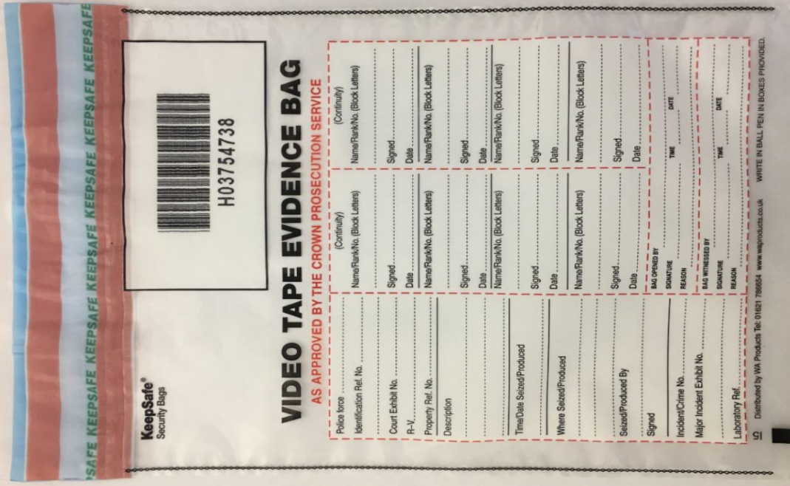
Where Seized/Produced
This is the location of the business where the CCTV has been recorded and produced from (usually the business address).
Time/date seized/produced
This is the time and date that the CCTV was burned to disc/USB. This will be the same time and date recorded in you statement.
Please sign on the line below.
Description
Describe the content e.g “CCTV Showing theft of fuel AB03ABC Make Model on DD/MM/YY”
Identification Ref. No
This will be the initials of the person who produced the CCTV followed by the number of their exhibit. For example. John Smith would be JS/1
Seized/produced by
Please circle ‘Produced’ and place your name underneath. This is to indicate that you have provided CCTV to Essex Police.

